**EXPERIMENT 3**

**Name- Isha Ipsita Dated – 17th of august 2022**

AIM: Working with Docker Volume

Steps to Complete:

1. View all Volume in Docker



1. Create a new Volume

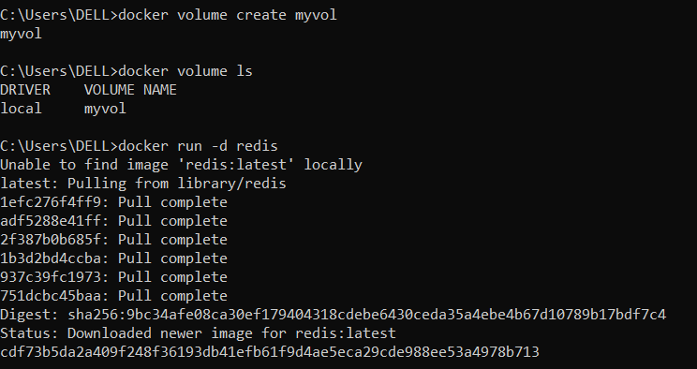

1. Mount a Volume with a container

**docker run -d redis docker ps,**

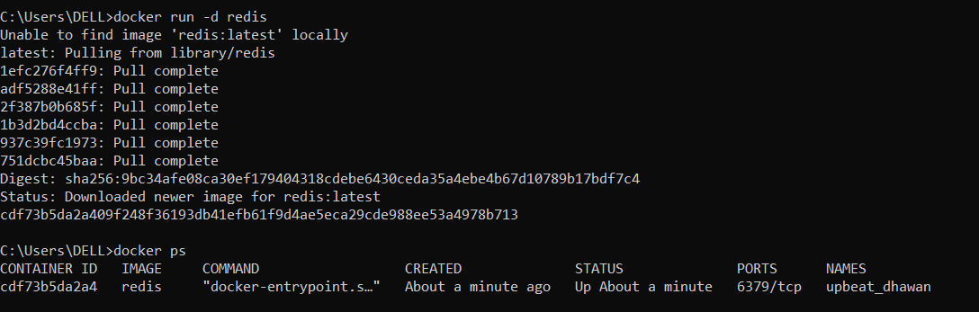

**docker inspect<containerid>**

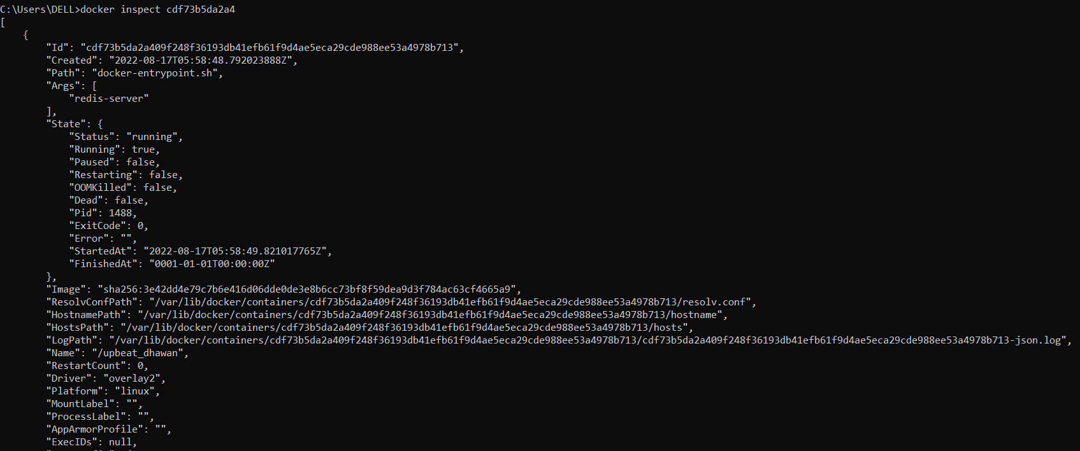

**docker run -it -v myvol:/data redis /bin/**bash (opens interactive terminal and -v flag is for mounting volume)

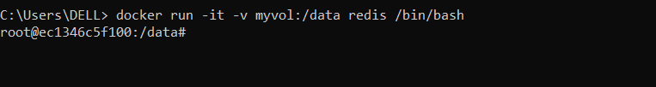

**ls**

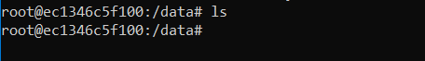

**Ls gives blank results as the volume is newly created and mounted**

**mkdir test, touch xyz.txt,exit**

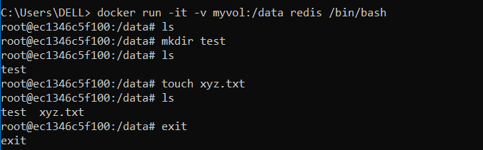

**docker ps-a**

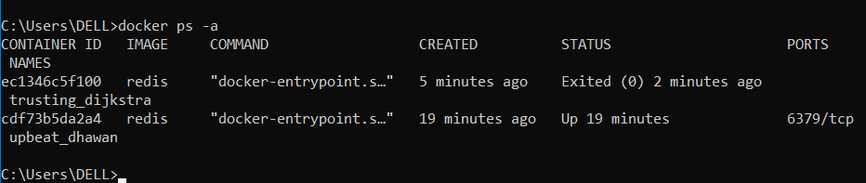

1. Create another container and Mount with the same Volume

Run again command- **docker run -it -v myvol:/data redis /bin/bash**

**(Creates another container mounted on the same volume)**

**Repeating all previous steps**

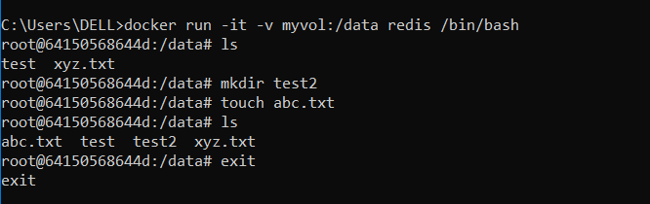

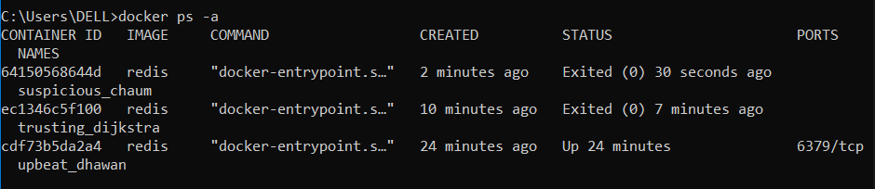

1. See the complete working of container



6. Exited from container and restart again to see the persistent of Docker

Volume

**Shows exited containers**

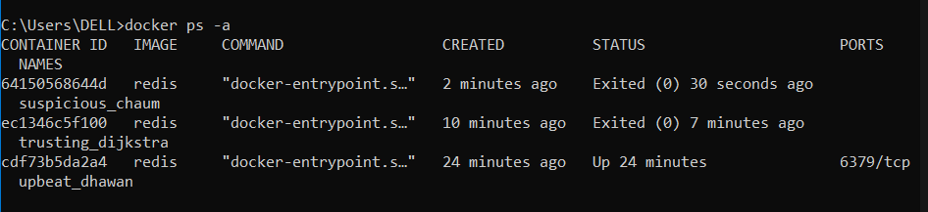

**Restarting command-**

**Docker start <cid> , docker attach<cid>, exit**

